DATE: 12.10.2018
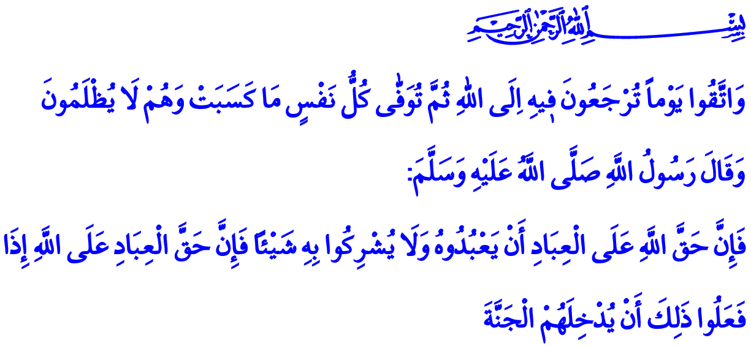
ALLAH THE ALMIGHTY GIVES EACH RIGHTHOLDER THEIR RIGHTS
Esteemed Believers!
Following the Hijrah, our Beloved Prophet (saw) declared the muhajirun and the ansar brothers. Salman al-Farsi (ra) and Abu Darda (ra) were among the Companions between whom the bonds of spiritual brotherhood were established. After being honored with Islam, Abu Darda (ra) decided not to engage in anything but worship Allah (swt). He quit commercial activities and even began to neglect his family. Seeing his situation, Salman (ra) warned his brother Abu Darda (ra) with the following words: “Your Lord has a right upon you. Your soul has a right upon you. Your family has a right upon you. So, give every rightholder their rights!” When Abu Darda (ra) conveyed these words of Salman to our Prophet (saw), The Messenger of Allah (saw) said, “Salman has spoken the truth.”
Honorable Muslims!
The source of the rights is Allah (swt). To Him (swt) belongs everything; He (swt) is the Owner of the earth, and the heaven. Allah (swt) is the One Who created us from nothing, and Who bestows upon us countless blessings. Therefore, it is He (swt) Whose rights we must observe most. Our Prophet (saw) informed us of our responsibility towards our Lord (swt) and the reward we would get when we have carried out this responsibility as: “The right of Allah upon His servants is, to worship Him alone and to associate none in worship with Him. If they do so, their right upon Allah is not to punish them, and let them in the Heaven.”
Dear Believers!
After servitude to Allah (swt) comes the observing of the rights of parents, who are the reason of our creation, in terms of significance before Him (swt), as stated in the Holy Qur’an: “And your Lord has decreed that you not worship except Him, and to parents, good treatment. Whether one or both reach old age [while] with you, say not to them [so much as], ‘uff’ and do not repel them but speak to them a noble word.”
As parents have rights upon their children, children have rights upon parents as well. It is our children’s right upon us to feed them with halal food, to raise them as morally good individuals who are heartily attached to their religion, beneficial to their homeland, nation, and humanity. In this respect, the Messenger of Allah (saw) stated in a hadith: “There is no gift that a father gives his child more valuable than good manners.”
Honorable Muslims!
Regardless of religion, race, or gender, every person has the right to life. It is a great sin to take a life, to violate the right to life of women, children, and innocent people for whatever reason except the boundaries determined by Allah (swt). Our Lord (swt) commands as follows in this regard: “But whoever kills a believer intentionally - his recompense is Hell, wherein he will abide eternally, and Allah has become angry with him and has cursed him and has prepared for him a great punishment.”
Esteemed Muslims!
According to our religion, we should approach not only humans but also animals with compassion and mercy. The consequence of persecuting animals and ignoring their rights to life will result in devastation in the afterlife. Indeed, the Prophet of Mercy (saw) told a woman who kept captive a cat and caused it to die of hunger that would go to hell because of this cruelty, on the other hand, informed man who gave water to a thirsty dog that he would be forgiven by Allah because an action as such would please Him.
Esteemed Believers!
It is stated in the Holy Qur’an, the book of truth and right, that: “And from their properties was [given] the right of the [needy] petitioner and the deprived.” The believers who are conscious that the needy have right in their wealth never hesitate to help the poor, the indigent, the orphan, and the forlorn. They are moderate in their expenditures, and avoid waste and vanity. They prefer simplicity and frugality. They know that the inhabitants of the earth have rights even in a morsel of bread.
Valuable Believers!
We also have responsibilities to the society we live in. To fulfill them, each of us should protect the rights of the public as well as the rights of individuals since the violation of rights is the greatest threat to the peace and brotherhood of a society. Behaviors such as condoning violence, polluting the environment, disobeying traffic rules, consuming electricity illegally, stockpiling, damaging the public property result in social tension and loss. Our Prophet (saw) describes the extent of this loss to the Hereafter as: “Neither gold nor silver money is available on the day of Judgment. Therefore, the rewards of those who have wronged their brothers are taken from them and given to the wronged person. If they do not have any rewards, then some of the sins of the wronged are taken and given to them.”
Brothers and Sisters!
Let us get prepared for the Day of Judgment, the day we shall be returned to Allah (swt), and that everyone shall be given exactly what they have deserved. Let us take refuge in Allah (swt) from defrauding, asking for what is not ours, and doing injustice by not giving the people their rights. Let us become sincere servants, respectful children, compassionate parents, and loyal spouses. Let us love the created for the sake of the Creator (swt), and show mercy to them.

Bukhari, Sawm, 51.
Ibn Hanbal, V, 239.
Isra, 17/23.
Tirmidhi, Birr wa Sila, 33.
Nisa, 4/93.
Bukhari, Bad’ al-Khalq, 16.
Bukhari, Musaqat, 9.
Dhariyat, 51/19.
Tirmidhi, Sifat al-Qiyamah, 2. General Directorate of Religious Services

